**High-quality Image Restoration Using Low-RankPatch Regularization and Global Structure Sparsity**

**ABSTRACT:**

Demand for better image quality focuses on designing of lot of image restoration methods. In this paper, we describe a hybrid method for removal of degradation from real images. This study focuses on image restoration and the proposed method is based on three major techniques, Phase preserving approach for denoising, normalization technique to give an image typical gray level intensity and Wavelets Transformation (WT) for reducing degradation. In WT, Discrete Wavelet Transform (DWT) provides most compact representation. In our implementation, we applied DWT to the image for separation of horizontal, vertical and diagonal details of the image.

**INTRODUCTION**

The article is concerned with PDE-based image restoration. A new model is introduced by hybridizing a non-convex variant of the total variation minimization (TVM) and the motion by mean curvature (MMC) in order to deal with the mixture of the impulse and Gaussian noises reliably. We suggest the essentially non-dissipative (ENoD) difference schemes for the MMC component to eliminate the impulse noise with a minimum (ideally no) introduction of dissipation. The MMC-TVM hybrid model and the ENoD schemes are applied for both grayscale and color images. For color image denoising, we consider the chromaticity-brightness decomposition with the chromaticity formulated in the angle domain. An incomplete CrankNicolson alternating direction implicit time-stepping procedure is adopted to solve those differential equations efficiently. Numerical experiments have shown that the new hybrid model and the numerical schemes can remove the mixture of the impulse and Gaussian noises, efficiently and reliably, preserving edges quite satisfactorily

Many applications in the modern digital age are based on images and therefore the resulting achievements must rely on their quality. Since images are not always in a good quality due to various types of noise (natural noise, defects in the sensors, transmission problems, etc.), it is important to eliminate the noise automatically and efficiently. Image restoration is historically one of the oldest concerns and still a necessary processing step for many other applications, as indicated . As the field requires higher levels of reliability and efficiency for the last two decades, mathematical image processing has become an important component. In particular, mathematical frameworks employing recent powerful tools of partial differential equations (PDEs) and functional analysis have been extensively studied to answer fundamental questions in image processing.

Image restoration is often necessary as a pre-processing for other operations such as segmentation, 3D construction, and compression; good denoising methods have strong demands. However, those PDE-based methods can show some drawbacks unless the governing equations are both incorporating appropriate parameters and discretized by suitable numerical schemes; the selected model parameters and numerical schemes should be able to capture characteristics of the image. Thus other important components of PDE-based approaches can be to develop appropriate numerical techniques for given PDE models and to adjust the models to incorporate more reliable features in image restoration. As a companion paper , the article aims to develop efficient and reliable numerical algorithms for the PDE-based restoration models such as the enhanced total variation minimization (ETVM) and the motion by mean curvature (MMC). In this article, we introduce a new hybrid model, combining MMC and ETVM, for the removal of the mixture of impulse noise and Gaussian noise. Also we apply the numerical procedures to color image denoising of which the major mathematical model is the ETVM, incorporating the brightness-chromaticity decomposition.

The article is organized as follows. In the next section, we present the models such as the ETVM and the MMC, as preliminaries. In the section, we also introduce a new model, called the αβω (ABO)-model which combines the aforementioned models. Section III contains numerical schemes to be incorporated in the ABO-model. We begin the section with the essentially non-dissipative (ENoD) difference schemes for the approximation of |∇u|. Then an incomplete alternating direction implicit (ADI) method is adopted for the time-stepping procedure. The ADI method was first introduced by Douglas, Peaceman, and Rachford, as a perturbation of the Crank-Nicolson difference equation, for solving the heat equation in 2D. Recently, Douglas and Kim suggested strategies for a virtual elimination of the splitting error of the ADI method and its variants. In the same section, we also suggest a hybrid algorithm combining the MMC and the ETVM; it has been numerically verified that the ENoD-MMC (MMC incorporating the ENoD schemes) is effective and efficient for the removal of impulse noise and preserves the edges satisfactorily. The remained noise (Gaussian noise) can be efficiently eliminated by the ETVM iteration, which also preserves edges satisfactorily; we apply the hybrid model for a color image denoising, which is formulated in the angle domain with the brightness-chromaticity decomposition .shows various numerical examples to demonstrate the effectiveness and efficiency of our numerical schemes in denoising the mixture of the impulse and Gaussian noises, for both grayscale and color images. The last section includes conclusions.

Image restoration finds best approximation of the original image from degraded version. But, image accuracy is not possible in the presence of blur and noise. The noise in digital images is arises during image acquisition, transmission and typically modelled as Gaussian type. Noise is unwanted signal that interferes with the original signal and degrades the visual quality of digital image.

We have considered PDE-based image denoising algorithms for the mixture of Gaussian and impulse noises, for both gray-scale and color images. As a companion paper , this article has first introduced a new hybrid model called the αβω (ABO)-model which combines a variant of the total variation minimization and the motion by mean curvature. The new model incorporating an incomplete Crank-Nicolson ADI (CN-ADI) time-stepping procedure has been verified to be efficient and effective for the removal of the mixture of Gaussian and impulse noises. For color images, we adopt a vectorvalued PDE system which involves the brightness-chromaticity decomposition, with the chromaticity being formulated in the angle domain. The CN-ADI procedure has been applied to the ABO-variant of the vector-valued PDE system; the resulting algorithm turns out to be very satisfactory, both efficient and reliable, for the noise removal for color images.

The Digital photo Processing is using laptop algorithms to participate in processing on digital graphics. As a subcategory or subject of digital, digital photograph processing has many advantages over processing. This research paper proposes a novel and improved restoration method utilizing blind snapshot deconvolution and curvelet become. More than a few blind and non-blind snapshot restoration procedures are studied to provide you with a better answer.

The Digital snapshot Processing allows for a wider variety of algorithms to be utilized to the input information and might hinder issues such because the build-up of noise and signal distortion in the course of processing. The giant discipline of Digital snapshot Processing is gaining quite a few research interest now days. In contemporary years, probably the most lively area in Digital snapshot Processing is of photograph Restoration. It is an subject underneath Digital image Processing where the fashioned photos are restored from the degraded ones. Photograph Restoration is to get better the longestablished and sharp picture from a degraded photograph with the aid of utilizing a mathematical mannequin of the blurring method. Right here, we first take an photograph which is referred to as usual photograph. The original photograph is degraded utilizing a degradation operate and by including a noise to it. This degraded image can then be restored utilising the little knowledge to be had concerning the degradation operate and supply of noise. The method of snapshot Restoration is split into two phases named as degradation section and restoration segment.

**LITERATURE SARVY**

Image Restoration is one of area related to image processing which deals with restoring an original and sharp image from corrupted image using a mathematical degradation and restoration model. In this proposed work, a comparative study analysis of simple, fast technique is given to remove noise of an image which is mostly introduced due to environmental changes or due to other issues. Researchers focus on the noise issues that changes image pixels value either on or off. To get an enough efficient method to remove the noise from the images is a greater challenge for the researchers. Noise plays an important role in degrading the image at the time of capturing or transmission of the image. There are many algorithms and filtering techniques available which have their own assumptions, merits and demerits depending upon the prior knowledge of the noise. Image smoothening is one of the most significant and widely used procedure in the image processing. Here, apart from noise a model, the light is also thrown on comparative analysis of noise removal techniques is done. This paper will present the different noise types to an image models and investigating the various noise reduction techniques and their advantages and disadvantages and also it will help the new researchers to have the detailed and comparative knowledge regarding image restoration and all its associated details.

Image restoration is an emerging field of image processing in which the focus is on recovering an original image from a degraded image. Image restoration can be defined as the process of removal or reduction of degradation in an image through linear or non-linear filtering. Degradation is usually incurred during the acquisition of the image itself. Just as in image enhancement, the ultimate goal in restoration is to improve an image. Enhancement is a subjective process while restoration is an objective process. Restoration tries to reconstruct by using a priori knowledge of the degradation phenomenon. It deals with getting an optimal estimate of the desired result. Some restoration techniques are best achieved in the spatial domain, while there are some cases where frequency domain techniques are better suited.

1. Tzikas, D.G., Likas, A.C., Galatsanos, N.P[2007][4] in this paper, they present a brand new Bayesian mannequin for the blind photo deconvolution (BID) main issue. The predominant novelty of this mannequin is the use of a sparse kernel-founded mannequin for the point unfold operate (PSF) that permits estimation of both PSF shape and support. In the herein proposed process, a effective model of the BID errors and an image prior that preserves edges of the reconstructed photo are additionally used. Sparseness, robustness, and upkeep of edges are carried out with the aid of making use of priors which are situated on the student's-t likelihood density perform (PDF). 2. Zhang X. F, Ye H, Tian W.F, Chen W.F [2007][5] on this paper, a regularized anisotropic diffusion filter was once offered and utilized to revive the DWI. The awarded filtering approach displayed well posedness and excellent maintenance of edges. To assess its effectivity in accounting for the Rician noise, the PSNR and MSSIM metrics were used for the primary time. The outcome bought from the unreal and real knowledge proved the easier performance of the offered filters. 3. XiaoliLian, TianfuWang[2008][6] The paper describes a modified homomorphicdeconvolution which is used to strengthen the great of clinical ultrasound photo. The proposed deconvolution performs the homomorphic filtering headquartered on the estimation of the factor-unfold

perform (PSF). Chiefly, the appliance of a non-regional way (NL-method) algorithm makes PSF estimation extra distinct for rejecting the White-Gaussian noise (WGN) readily. They validate our system for exceptional radiofrequency (RF) pics with resolution growth. 4. Mateos, J., Bishop, T.E., Molina, R., Katsaggelos, A.K[2009][9] on this paper they gift a brand new Bayesian methodology for the restoration of blurred and noisy photos. Bayesian ways depend on snapshot priors that encapsulate prior photograph abilities and avert the in poor healthposedness of photo restoration issues. They use a spatially various snapshot prior using a gamma-normal hyper prior distribution on the regional precision parameters. The proposed restoration manner is when compared with other photo restoration tactics, demonstrating its expanded performance. 5. Wei-Wen Wu, Jin-HuiZhong, Zhi-Yan Wang[2010][11] picture degradation is related to many factors. They first supply a short introduction for the optical thought of defocused photo, after which discuss the items of defocusing and introduce an effective approach to calculate the PSF (point spread perform) of defocus. With the Gaussian model and degradation of defocus in parameter estimation, they recommend a new method to reconstruct defocused photo, which is founded on LucyRichardson Algorithm mixed with Wiener Adaptive filtering disposing of the noise. The simulation results exhibit that the new system can obtain excellent recovery outcome. 6. QianzongBaoQingchunLi[2010][10] photographdenoising is an predominant step in snapshot processing. On this paper, a brand new image restoration strategy headquartered on the index set of gigantic Curvelet coefficients constrains is proposed. Firstly, the noisy picture is processed by way of Curveletthresholding method, while, the index set is preserved by the curvelet coefficients whose absolute magnitude is greater than the thresholding worth. Secondly, a complementary photo is obtained by using applying the index set to the difference photograph between the normal noisy picture and the reconstructed photograph through thresholding system. I. Xue Li, GaoShesheng, Wang Jianchao [2010][12] In nonlinear and non-Gaussian techniques, particle filtering is effective but it is complex to prefer the importance distribution function and diverges more greatly. Aiming at this drawback, the paper represents effective unscented regularized particle filtering to give a boost to the efficiency of filtering. This algorithm is more suitable for filtering calculation in nonlinear approach, now not only since overcomes the boundaries of the general particle filter and uses the identical weightbut additionally takes capabilities of the excessive effectivity of unscented particle filtering and regularized particle filtering. II. Ramya, S., Mercy Christial, T[2011][13] photo restoration is the approach of getting better the customary picture from the degraded snapshot. Aspire of the undertaking is to restore the blurred/degraded pics utilising Blind Deconvolution algorithm. The principal challenge of photo deblurring is to de-convolute the degraded image with the PSF that precisely describe the distortion. To begin with, the common picture is degraded making use of the Degradation model. It can be carried out via Gaussian filter which is a low-pass filter used to blur an snapshot. In the edges of the blurred image, the ringing outcomes can also be detected using Canny part Detection approach and then it may be removed before restoration process. III. Yang-Chih Lai, Chih-Li Huo, YuThis be taught focuses on Gaussian blur estimation for blind photograph deconvolution (BID) problem. In BID difficulty, it handiest uses blurred photo and not more information of factor unfold perform (PSF) to restore the got the blurred photo. Due to fix the got photo, step one is to identify the proper PSF model. The received picture does no longer uniquely outline the PSF. However these are many applications the place the got photograph have been blurred either by using an unknown or a in part recognize PSF. Hence, this paper pick Gaussian blur photo for further research, which utilized the particle swarm optimization algorithm to search for the unknown PSF. The target perform for browsing the parameters of PSF is based on area detection and picture morphology. It may well determine the parameters of PSF exactly. Subsequently, the feasibility and validity of proposed algorithm are verified with the aid of a few simulations. 7. ChongliangZhong, Jinbao Fu, YalinDing[2011][14] In keeping with the exact situation, when excessive fine and excessive precision are required for the photo, both until now and afterwards compensation should be used. On this paper, they use Lucy-Richardson algorithm to compensate image motion of a designated aviation digicam as an afterwards compensation. To begin with, they analyze the imaging principle of the camera and the motives that motive image movement. Then they have a quick introduce of the Amandeep Kaur,2012[15] The Richardson-Lucy iterative algorithm is the deconvolution procedure which is most popular used in the field of image processing. The fundamental characteristic is that it do not predicament the kind of noise affecting the photograph DongqingXu (IEEE 2013)[16] in their paper ―The image Restoration system situated on photo Segmentation and multiple function Fusion‖ they bear in mind the neighborhood correlation of natural image, makes use of mean Shift clustering segmentation algorithm to separate the customary enter photo, limits the hunt scope in the related texture region to search out the exceptional matching block; whilst for locating matching algorithm of essentially the most compatible texture block, by way of the analysis of snapshot texture characteristic, the constitution traits and the distance between restore block and similar block, this paper places ahead a style of texture similarity block matching algorithm based on texture, structure and the distance. 4.Problem Statement Quite often, the classification of an photo’s pixel belonging to one in all the “objects” (i.E., classes) composing the photo is established on some common feature(s), or resemblance to a couple sample. So as to assess which are the points that can lead to a victorious classification, some apriori expertise or/and assumptions about the picture are equally required. 5. PROBLEM FORMULATION/NEED AND SIGNIFICANCE OF PROPOSED RESEARCH WORK The implementation of photo restoration algorithms in quite a lot of fields is gaining a lot of research interest now days. There are quantity of present restoration algorithms viz. Blind image Deconvolution (BID) method, Lucy Richardson method (LRT), Weiner Filtering procedure (WFT) and Regularized Filtering technique (RFT). All such algorithms are centered on unique varieties of filters. For the implementation of image restoration algorithms, the most important hindrance is to get well the degraded snapshot to a larger extent. It's indispensable that resultant picture acquired after applying a restoration algorithm must be close to the customary snapshot. Our proposed research would be on hybrid restoration technique .

The foremost purpose of this work is to carry out a comparative study to evaluate the performance of more than a few photo restoration algorithms making use of pics of distinct sizes and to improve a new restoration technique. First of all, a gain knowledge of and implementation of various restoration tactics viz. Lucy Richardson, Weiner filtering and Regularized Filtering and Blind image Deconvolution is done. Then all these techniques are demonstrated utilising snap shots of extraordinary sizes. Quite a lot of sizes are taken in order to scan the performance of all procedures. For performance analysis and assessment, parameters like PSNR (peak signal to Noise ratio), MSE (imply square Error) and RMSE (Root imply rectangular Error) are used. Situated on the efficiency assessment, an effective technique will probably be found after which this method will probably be extra elevated. For this reason, a brand new restoration technique is developed and applied. A Graphical consumer Interface (GUI) instrument is required for the interactive and handy restoration of various pics. Accordingly a GUI restoration device can be designed centered on the restoration algorithms.

**EXISTING SYSTEM**

Comparative Analysis of Image Denoising Techniques:

Visual information transmitted in the form of digital images is becoming a major method of communication in the modern age. But the main drawback in digital images is inheritance of noise while their acquisition or transmission. Removing noise from digital images is a big challenge for researchers. Several noise removal algorithms have been proposed till date. Choice of denoising algorithm is application dependent and depends upon the type of noise present in the image. Every algorithm has its own assumptions, advantages and limitations. This paper presents a comparative analysis of various noise suppression algorithms.

Digital images play an important in research and technology such as geographical information systems as well as it is the most vital part in the field of medical science such as ultrasound imaging, X-ray imaging, Computer tomography and MRI. A very large portion of digital image processing includes image restoration. Image restoration is a method of removal or reduction of degradation that are incurred during the image capturing. Degradation comes from blurring as well as noise due to the electronic and photometric sources. Blurring is the form of bandwidth reduction of images caused by imperfect image formation process such as relative motion between camera and original scene or by an optical system that is out of focus. Noise is unwanted signal that interferes with the original signal and degrades the visual quality of digital image. The main sources of noise in digital images are imperfect instruments, problem with data acquisition process, interference natural phenomena, transmission and compression [1]. Image denoising forms the preprocessing step in the field of photography, research, technology and medical science, where somehow image has been degraded and needs to be restored before further processing.

Wavelet transform is a mathematical function that analyzes the data according to scale or resolution. Noise reduction using wavelets is performed by first decomposing the noisy image into wavelet coefficients i.e. approximation and detail coefficients. Then, by selecting a proper thresholding value the detail coefficients are modified based on the thresholding function. Finally, the reconstructed image is obtained by applying the inverse wavelet transform on modified coefficients. Basic procedure for all thresholding method is 1. Calculate DWT if the Image. 2. Threshold the wavelet components. 3. Compute IDWT to obtain denoised estimate. There are two thresholding functions frequently used i.e. Hard Threshold, Pan et al. [9], Soft threshold. HardThresholding function keeps the input if it is larger than the threshold; otherwise, it is set to zero. Soft-thresholding function takes the argument and shrinks it toward zero by the threshold. Soft-thresholding rule is chosen over hardthresholding, for the soft-thresholding method yields more visually pleasant images over hard thresholding. A result may still be noisy. Large threshold alternatively, produces signal with large number of zero coefficients. This leads to a smooth signal. So much attention must be paid to select optimal threshold.

The comparative study of various denoising techniques for digital images shows that wavelet filters outperforms the other standard spatial domain filters. Although all the spatial filters perform well on digital images but they have some constraints regarding resolution degradation. These filters operate by smoothing over a fixed window and it produces artifactsaround the object and sometimes causes over smoothing thus causing blurring of image. Wavelet transform is best suited for performance because of its properties like sparsity, multiresolution and multiscale nature. Thresholding techniques used with discrete wavelet are simplest to implement.

”Novel Method of Image Restoration by using Different Types of Filtering Techniques:

During the process of image acquisition, sometimes images are degraded by various reasons. Image restoration is a challenging task in the field of Image processing. The process of recovering such degraded or corrupted image is called Image Restoration. Restoration process improves the appearance of the image. The degraded image is the convolution of the original image, degraded function, and additive noise. The process of restoration is deconvolved this degraded image to obtain noiselessly and deblurred original image. Various methods available for image restoration such as inverse filter, Weiner filter, constrained least square filter, blind deconvolution method etc. some of the methods are either linear or non-linear method helps to remove noise and blur from the image. In this description and comparison of restoration techniques are mentioned. In this paper, various spatial domain filters are discussed which are used to remove noise from the images.

Images are produced to record or display useful information or details .Due to flaws in the imaging and capturing process, however, the recorded image always represents a degraded version of the original scene. The undoing of these imperfections is critical to many of the successive image processing tasks .There exists a huge range of different degradations, which should be taken into account, for example noise, geometrical degradations, illumination and color imperfections (under-exposure/over-exposure, saturation) and blur. The area of image restoration (sometimes referred to as image deblurring or image deconvolution) is concerned with the reconstruction or estimation of the uncorrupted image from a blurred and noisy image. Essentially, it tries to perform an operation on the image which is the inverse of the imperfections in the image formation system . In the use of image restoration methods, the characteristics of the degrading system and the noise are assumed to be known from before. In practical situation, however one may not be able to obtain this information directly from the image formation process. The aim of blur identification is to determine the attributes of imperfect imaging system from the observed degraded image itself prior to the restoration process. A. What is image restoration? Image Restoration refers to a group of methods or techniques that aim to remove or reduce the degradations that have occurred while the digital image was being obtained. All natural images when displayed have gone through some sort of degradation: • The degradation may occur during display mode •The degradation may occur when camera is in the acquisition mode, or • During processing mode degradations may also takes place. The degradations may be due to • The degradation may occur due to sensor noise • The degradations may Blur due to camera misfocus• The degradation may occur due to relative object-camera motion • The degradation may occur due to random atmospheric turbulence • The degradation may occur due to some other reasons also. In most of the existing image restoration methods we assume that the degradation process can be described using a mathematical model. B. How much image can be restored? It depends on how much we know about the original image, information contains in the original image how much the image is degraded, reasons behind the degradations and how accurate our degradation models are and with what accuracy it can be implemented. In this paper the objective and definition of image restoration is addressed. We also give a brief introduction about various blurring and deblurring techniques. Each technique has its own advantages and disadvantages. This paper will be helpful for the researchers in understanding the concept of image restoration and deblurring techniques who are new in this field .Research work is taking place on image fusion techniques using two algorithms, but there is scope for the improvement, If we can use more than two algorithms and more samples can be used results could have been better. The work will be carried out on MATLAB image processing tool box..

”Restoring Degraded Astronomy Images using a Combination of Denoising and Deblurring Techniques:

The aim of image restoration is to restore the image affected by degradations to the most desired form. It comprises a set of techniques applied to the degraded image to remove or reduce the cause of degradations. This study focuses on Astronomy images. Astronomy images suffer from mainly two types of degradations: atmospheric turbulence blur and additive white Gaussian noise. This study presents a new method to restore astronomy images by proposing a hybrid method that combines three techniques to restore a degraded image. The first technique is phase preserving algorithm used for the denoising operation. Then a normalization operation is employed to provide the image its natural grayscale intensity. After that Richardson Lucy deblurring algorithm is used to deblur the image depending on the Point Spreading Function (PSF) determined earlier. When the deblurring process is completed, the anticipated image will be in the most desirable form.

Astronomy images are captured and saved in many different environments, situations, and methods. Due to that, the chances of having errors or problems during the process of capturing the image and saving it are also increased and for that, these problems must be taken into consideration . Various images illustrate captured scenes in an unacceptable situation. Since imaging systems employed to acquire images are imperfect, the surroundings under which images are gained are usually less than perfect; a captured image regularly demonstrates a corrupted edition of the original scene. The problems that occur to an image which is also called degradations consist of many kinds like noise, geometrical degradations (pin cushion distortion), illumination and color imperfections (under/overexposure, saturation), and blur [2]. Many factors lead to have degradations in an image, for instance, the surrounding atmosphere, the procedure of acquiring an image, the medium of recording an image. Due to these factors, the image that is essentially recorded often becomes unsuccessful to represent the scene sufficiently. In the case of astronomy images, many captured images suffer from two types of degradations: atmospheric turbulence blur, and additive white Gaussian noise . The atmospheric turbulence blur degrades images by many ways like, images taken by cameras viewing scenes from long distances, The earth turbulent atmosphere, long exposure imaging due to a low illumination environment , and dust particles on the surface of the lens are the main reason for the blur to happen .The additive white Gaussian noise degrades images in many ways for instance, image transmission from source to destination, the time the image is captured and generated or an error at the imaging system . Also noise degrades an image because of capturing the image in a low illumination environment, errors in transmission , and low-contrast objects . Consider the original image is (F), (H) is the blur operator who would be convolved with the original image to give the blurred image, the noise (N) will be added to the image, as in the following equation :

The restoration process in the situation of the existence of blur and noise combined together is complicated. The reason is that, the blur is a low pass signal, and the noise is a high pass signal. However, the high pass filters help to deblur the image (sharpening the image), but in this case, the noise will be amplified. Furthermore, the low pass filters help to denoise the image (Soften the image), but in this case, the blur will be amplified. Unfortunately, in this situation when trying to restore a blurry and noisy image, the effect will be adverse. Due to that reason, an alternative method has been considered to remove the noise and blur separately one after another . The aim of this study is to restore an image that has an atmospheric turbulence blur and additive Gaussian noise mixed together in one image. The proposed method is trying to restore it as much as possible to look like the original one.

This study focuses on Astronomy images. Several problems have been identified in the captured images, but the focus of this research is mainly on two types of degradations: the atmospheric turbulence blur and additive white Gaussian noise. The use of multiple techniques in the restoration operation is very important. This is due to the specific characteristic of each technique in its own domain of problems. Thus, the combination of series of techniques is thought and proven to deliver a better result in image quality. As a future work, the current method can be improved by applying more enhancement techniques in the restoration operation to obtain better results, also employing more than one deblurring algorithm would lead to more precise results, furthermore, Utilizing a fine algorithm to estimate the point spreading function (PSF) will result in more accurate outcome in the deblurring process.

**PROPOSED SYSTEM**

**Image Restoration:**

Image Restoration is the operation of taking a corrupt/noisy image and estimating the clean, original image. Corruption may come in many forms such as [motion blur](https://en.wikipedia.org/wiki/Motion_blur), [noise](https://en.wikipedia.org/wiki/Image_noise) and camera mis-focus. Image restoration is performed by reversing the process that blurred the image and such is performed by imaging a point source and use the point source image, which is called the Point Spread Function (PSF) to restore the image information lost to the blurring process.

Image restoration is different from [image enhancement](https://en.wikipedia.org/wiki/Image_enhancement) in that the latter is designed to emphasize features of the image that make the image more pleasing to the observer, but not necessarily to produce realistic data from a scientific point of view. Image enhancement techniques (like [contrast stretching](https://en.wikipedia.org/wiki/Contrast_stretching) or de-blurring by a nearest neighbor procedure) provided by imaging packages use no *a priori* model of the process that created the image.

With image enhancement noise can effectively be removed by sacrificing some resolution, but this is not acceptable in many applications. In a [fluorescence microscope](https://en.wikipedia.org/wiki/Fluorescence_microscope), resolution in the z-direction is bad as it is. More advanced image processing techniques must be applied to recover the object.

The objective of image restoration techniques is to reduce noise and recover resolution loss. Image processing techniques are performed either in the image domain or the frequency domain. The most straightforward and a conventional technique for image restoration is [deconvolution](https://en.wikipedia.org/wiki/Deconvolution" \o "Deconvolution), which is performed in the frequency domain and after computing the [Fourier transform](https://en.wikipedia.org/wiki/Fourier_transform) of both the image and the PSF and undo the resolution loss caused by the blurring factors. This deconvolution technique, because of its direct inversion of the PSF which typically has poor matrix [condition number](https://en.wikipedia.org/wiki/Condition_number), amplifies noise and creates an imperfect deblurred image. Also, conventionally the blurring process is assumed to be shift-invariant. Hence more sophisticated techniques, such as regularized deblurring, have been developed to offer robust recovery under different types of noises and blurring functions. It is of 3 types: 1. Geometric correction 2. radiometric correction 3. noise removal

The field of digital image processing deals not only with the extraction of features, analysis of images and restoration of images but also with the process of enhancement, filtering and restoration of images. Image restoration is one of the basic steps of processing that deals with making certain improvements in a digital image based on some predefined criteria .The prime objective of restoration is to build or reconstruct an image that has been degraded based on some prior knowledge regarding the phenomena of degradation of images .The process of restoration is objective in nature that is; it aims at a specific goal like removal of blur in an image by means of a deblurring function .The techniques that are used in the restoration of images can be formulated in spatial domain or in frequency domain. Image restoration is based on probabilistic models of image degradation. Thus image restoration tends to make the images look better in appearance.

Image processing is a technique in which we enhance the data (raw images) sensed from the sensors placed on different artifacts of the life for various specified applications. The result is of greater quality as the objects are clearly visible as compared to the original sensed image. There are various fundamental steps involved in the image processing that is representation of images, preprocessing of images, enhancement, restoration, analysis, reconstruction of images and image data compression. The concerns of the image restoration are the removal or reduction of degradations which are included during the acquisition of images e.g.; Noise, pixel value errors, out of focus blurring or camera motion blurring using prior knowledge of the degradation phenomenon. This means it deals with the modelling of the degradation and applying the process (inverse) to reconstruct the image. The image restoration has got a wide scope of usage.

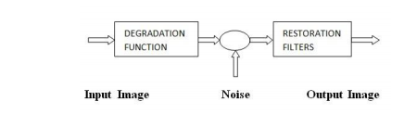

The purpose of image restoration is to compensate for or undo effects. The orientation of the image restoration techniques is towards modelling the degradations such as blur and noise which involves the applications of various filters to obtain the original scene approximation. Input image is degraded by a degradation function say h(x,y) and channel transmission noise n(x,y), degraded image g(x,y) can be obtained. In mage restoration the target is to obtain the approximate target to the input. The blurred image can be described with the following equation .



Restoration of images is a difficult problem to resolve. The main objective of this work is to carry out a comparative study. Though every technique has got its own way of dealing with the problem and have their own pros and cons. It is concluded from the above explanations that usage of the techniques is governed by the understanding, requirement and the standard of the output needed. Before the application of the any filtering technique; it is supposed to have the better understanding that is it requires proper analysis, though some of the researches have categorically claimed that wiener and Lucy-Richardson are expected to give the better results.

Images are often degraded during the data acquisition process. The degradation may involve blurring, information loss due to sampling, quantization effects, and various sources of noise. The purpose of image restoration is to estimate the original image from the degraded data. Applications range from medical imaging, astronomical imaging, to forensic science, etc. Often the benefits of improving image quality to the maximum possible extent far outweigh the cost and complexity of the restoration algorithms involved.

The most general degradation model is that of a conditional pdf for the data y given the original image x, as depicted in it. The domains of x and y are generally (but not always) discrete. For instance, x and y could be images with the same number N of pixels.

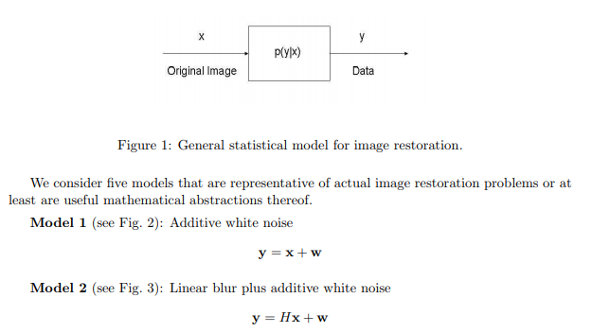

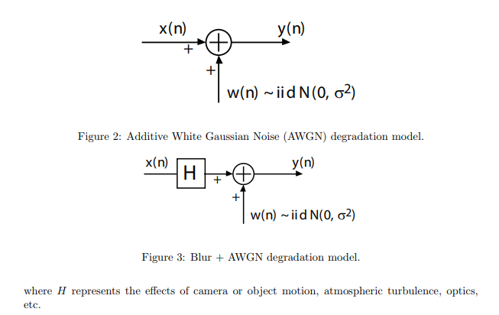

Consider the following imaging system for transmission tomography [1, Ch. 10]. An object (typically a slice of a patient’s body) is irradiated along direction θ by an X-ray or gamma-ray source. These high-energy photons travel through the object and are subsequently detected and counted. At each location (x, y) inside the object, the photon is subject to possible capture, with probability f(x, y)dl over an elementary path segment of length dl. The intensity of the surviving photons that travelled along flight path L is therefore given by

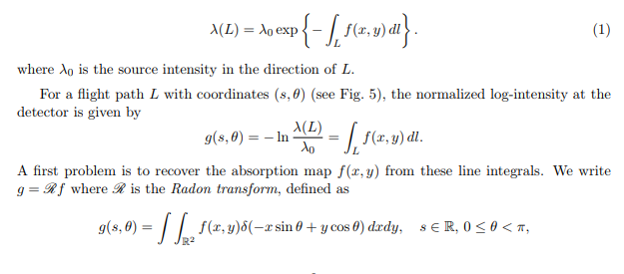

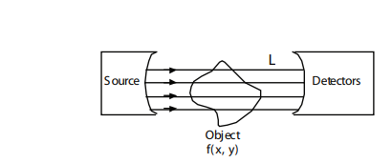

Figure: Irradiation of body in transmission tomography.

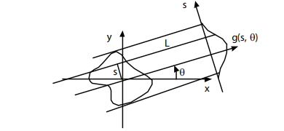

Figure: Parameterization of flight path L by (s, θ)

and δ(·) is the Dirac impulse. For high-count imaging modalities, the quantum nature of the measurements is often ignored, and the problem becomes one of inverting the Radon transform. In low-count imaging modalities, a more accurate, physics-based model taking into account Poisson statistics is desirable. The data collected by the detectors are independent Poisson random variables

Phase Preserving Algorithm:

The forthcoming generation of SENTINEL-1 SAR demands for high precision phase preserving processors, that would handle the relatively large fractional bandwidth and the extended squint angle span due to TOPSAR. At the same time, efficiency is a must to handle the data rate that comes out from the two polarimetric channels and to cope for fast delivery of products. The paper discusses two different wavenumber-domain kernels capable of processing the data acquired in STRIPMAP mode. These kernels are designed to handle the curved orbit geometry with a very low phase error. Thereafter, it discusses the implementation of a phase preserving TOPSAR processor that takes advantage of the STRIPMAP kernels 1 . Here again, an analysis of phase error is made basing both on the transfer function and the results achieved by processing simulated data.

Burst-mode data is obtained when a SAR system is operated in ScanSAR mode. Missing data in the burst gaps makes it difficult to use traditional phase-preserving algorithms to produce single look complex (SLC) data. In this paper, three phase-preserving algorithms for burst-mode data compression are examined and compared to find the best algorithm for precision processing applications such as interferometry.

With the increasing interest in SAR interferometry (InSAR), it is important that SAR processing algorithms be phase preserving. In the last few years, many sophisticated phase-preserving SAR algorithms, such as classical Range Doppler (RD), modified RD, SPECAN (de-ramp and FFT) and chirp scaling have been published. These algorithms work well on continuous-mode data, but have to be modified when applied to burst-mode data, because the spectrum of the data varies with time. This paper will discuss three phase-preserving algorithms for burst-mode data, two modified from the RD algorithm, and one from the SPECAN algorithm. We show the simulation results using these algorithms, and by comparing these results, the best algorithm will be recommended.

With the increasing interest in SAR interferometry (InSAR), it is important that SAR processing algorithms be phase preserving. In the last few years, many sophisticated phase-preserving SAR algorithms, such as classical Range Doppler (RD), modified RD, SPECAN (de-ramp and FFT) and chirp scaling have been published. These algorithms work well on continuous-mode data, but have to be modified when applied to burst-mode data, because the spectrum of the data varies with time. This paper will discuss three phase-preserving algorithms for burst-mode data, two modified from the RD algorithm, and one from the SPECAN algorithm. We show the simulation results using these algorithms, and by comparing these results, the best algorithm will be recommended.

The difference between continuous-mode and burst-mode data. The Doppler spectrum of a continuous-mode target covers the full antenna bandwidth, the same for each target. However, in burst mode, different targets will have a different spectral distribution, depending on the target's azimuth location.

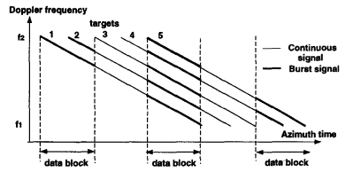

Figure: Target spectral distribution in continuous and burst mode

This discontinuous, non-stationary Doppler spectrum makes it difficult to apply traditional phase preserving compression algorithms. Modifications of the algorithms are necessary for the compression of burst-mode data.

we have analyzed and compared three modified algorithms for precision processing burst-mode data. Bamler’s algorithm uses all the data information, but gives a spiky pulse. Comparing these three algorithms, we can conclude that the SIFFT and SPECAN algorithms are favored for interferometric application of burst-mode data. Out of the two, the SIFFT algorithm has the advantage that it follows the heritage of RD, and that the azimuth spacing in SPECAN is a function of the azimuth FM rate.

The impulse response function (IRF) of a SAR system with the acquisition geometry shown in Fig. 1 for a point target in (x, r), is:

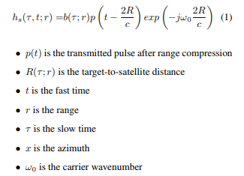

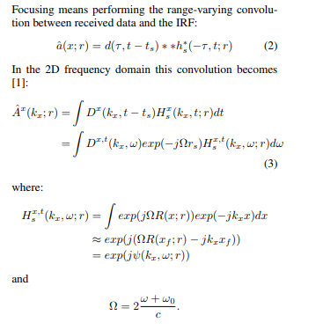

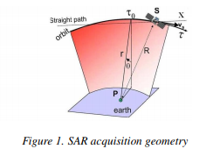

In this paper we are going to discuss two different focusing algorithms designed to handle the curved orbit geometry with a very low phase error. The first one is called CZ-GSI, it was developed by Politecnico di Milano and Aresys, and it is presented in section two.

The paper has discussed two different wavenumberdomain kernels capable of processing the data acquired in STRIPMAP and TOPSAR modes. These kernels are designed to handle the curved orbit geometry with a very low phase error. The CZ-GSI processor is more efficient and can cope with huge orbital arcs. On the other hand, the enhanced RD algorithm can easily implement the stretch in the range direction useful with large bandwidth.

**Normalization:**

The inventor of the relational model Edgar Codd proposed the theory of normalization with the introduction of First Normal Form, and he continued to extend theory with Second and Third Normal Form. Later he joined with Raymond F. Boyce to develop the theory of Boyce-Codd Normal Form.

Theory of Data Normalization in SQL is still being developed further. For example, there are discussions even on 6th Normal Form. **However, in most practical applications, normalization achieves its best in 3rd Normal Form**. The evolution of Normalization theories is illustrated below-

 Database normalization is the process of structuring a relational databasein accordance with a series of so-called [normal forms](https://en.wikipedia.org/wiki/Database_normalization#Normal_forms) in order to reduce [data redundancy](https://en.wikipedia.org/wiki/Data_redundancy) and improve [data integrity](https://en.wikipedia.org/wiki/Data_integrity). It was first proposed by [Edgar F. Codd](https://en.wikipedia.org/wiki/Edgar_F._Codd) as an integral part of his [relational model](https://en.wikipedia.org/wiki/Relational_model).

Normalization entails organizing the [columns](https://en.wikipedia.org/wiki/Column_(database)) (attributes) and [tables](https://en.wikipedia.org/wiki/Relation_(database)) (relations) of a database to ensure that their [dependencies](https://en.wikipedia.org/wiki/Dependency_theory_(database_theory)) are properly enforced by database integrity constraints. It is accomplished by applying some formal rules either by a process of *synthesis* (creating a new database design) or *decomposition* (improving an existing database design).

A basic objective of the first normal form defined by Codd in 1970 was to permit data to be queried and manipulated using a "universal data sub-language" grounded in [first-order logic](https://en.wikipedia.org/wiki/First-order_logic).[[1]](https://en.wikipedia.org/wiki/Database_normalization#cite_note-1) ([SQL](https://en.wikipedia.org/wiki/SQL) is an example of such a data sub-language, albeit one that Codd regarded as seriously flawed.)[[2]](https://en.wikipedia.org/wiki/Database_normalization#cite_note-2)

The objectives of normalization beyond 1NF (first normal form) were stated as follows by Codd:

1. To free the collection of relations from undesirable insertion, update and deletion dependencies.
2. To reduce the need for restructuring the collection of relations, as new types of data are introduced, and thus increase the life span of application programs.
3. To make the relational model more informative to users.
4. To make the collection of relations neutral to the query statistics, where these statistics are liable to change as time goes by.

— *E.F. Codd, "Further Normalization of the Data Base Relational Model"*[[3]](https://en.wikipedia.org/wiki/Database_normalization#cite_note-3)

[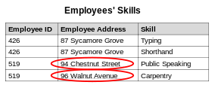](https://en.wikipedia.org/wiki/File:Update_anomaly.svg)

An update anomaly. Employee 519 is shown as having different addresses on different records.

[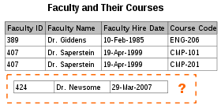](https://en.wikipedia.org/wiki/File:Insertion_anomaly.svg)

An insertion anomaly. Until the new faculty member, Dr. Newsome, is assigned to teach at least one course, his or her details cannot be recorded.

[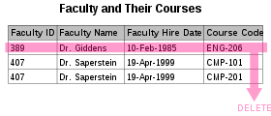](https://en.wikipedia.org/wiki/File:Deletion_anomaly.svg)

A deletion anomaly. All information about Dr.Giddens is lost if he or she temporarily ceases to be assigned to any courses.

When an attempt is made to modify (update, insert into, or delete from) a relation, the following undesirable side-effects may arise in relations that have not been sufficiently normalized:

* Update anomaly. The same information can be expressed on multiple rows; therefore updates to the relation may result in logical inconsistencies. For example, each record in an "Employees' Skills" relation might contain an Employee ID, Employee Address, and Skill; thus a change of address for a particular employee may need to be applied to multiple records (one for each skill). If the update is only partially successful – the employee's address is updated on some records but not others – then the relation is left in an inconsistent state. Specifically, the relation provides conflicting answers to the question of what this particular employee's address is. This phenomenon is known as an update anomaly.
* Insertion anomaly. There are circumstances in which certain facts cannot be recorded at all. For example, each record in a "Faculty and Their Courses" relation might contain a Faculty ID, Faculty Name, Faculty Hire Date, and Course Code. Therefore, we can record the details of any faculty member who teaches at least one course, but we cannot record a newly hired faculty member who has not yet been assigned to teach any courses, except by setting the Course Code to null. This phenomenon is known as an insertion anomaly.
* Deletion anomaly. Under certain circumstances, deletion of data representing certain facts necessitates deletion of data representing completely different facts. The "Faculty and Their Courses" relation described in the previous example suffers from this type of anomaly, for if a faculty member temporarily ceases to be assigned to any courses, we must delete the last of the records on which that faculty member appears, effectively also deleting the faculty member, unless we set the Course Code to null. This phenomenon is known as a deletion anomaly.

Minimize redesign when extending the database structure:

A fully normalized database allows its structure to be extended to accommodate new types of data without changing existing structure too much. As a result, applications interacting with the database are minimally affected.

Normalized relations, and the relationship between one normalized relation and another, mirror real-world concepts and their interrelationships.

Example:Querying and manipulating the data within a data structure that is not normalized, such as the following non-1NF representation of customers, credit card transactions, involves more complexity than is really necessary:

|  |  |  |
| --- | --- | --- |
| Customer | Cust. ID | Transactions |
| Abraham | 1 | |  |  |  | | --- | --- | --- | | Tr. ID | Date | Amount | | 12890 | 14-Oct-2003 | −87 | | 12904 | 15-Oct-2003 | −50 | |
| Issac | 2 | |  |  |  | | --- | --- | --- | | Tr. ID | Date | Amount | | 12898 | 14-Oct-2003 | −21 | |
| Jacob | 3 | |  |  |  | | --- | --- | --- | | Tr. ID | Date | Amount | | 12907 | 15-Oct-2003 | −18 | | 14920 | 20-Nov-2003 | −70 | | 15003 | 27-Nov-2003 | −60 | |

To each customer corresponds a 'repeating group' of transactions. The automated evaluation of any query relating to customers' transactions, therefore, would broadly involve two stages:

1. Unpacking one or more customers' groups of transactions allowing the individual transactions in a group to be examined, and
2. Deriving a query result based on the results of the first stage

For example, in order to find out the monetary sum of all transactions that occurred in October 2003 for all customers, the system would have to know that it must first unpack the *Transactions* group of each customer, then sum the *Amounts* of all transactions thus obtained where the *Date* of the transaction falls in October 2003.

One of Codd's important insights was that structural complexity can be reduced. Reduced structural complexity gives users, application, and DBMS more power and flexibility to formulate and evaluate the queries. A more normalized equivalent of the structure above might look like this:

|  |  |
| --- | --- |
| Customer | Cust. ID |
| Abraham | 1 |
| Issac | 2 |
| Jacob | 3 |

|  |  |  |  |
| --- | --- | --- | --- |
| Cust. ID | Tr. ID | Date | Amount |
| 1 | 12890 | 14-Oct-2003 | −87 |
| 1 | 12904 | 15-Oct-2003 | −50 |
| 2 | 12898 | 14-Oct-2003 | −21 |
| 3 | 12907 | 15-Oct-2003 | −18 |
| 3 | 14920 | 20-Nov-2003 | −70 |
| 3 | 15003 | 27-Nov-2003 | −60 |

In the modified structure, the key is {Cust. ID} in the first relation, {Cust.ID, Tr ID} in the second relation.

Now each row represents an individual credit card transaction, and the DBMS can obtain the answer of interest, simply by finding all rows with a Date falling in October, and summing their Amounts. The data structure places all of the values on an equal footing, exposing each to the DBMS directly, so each can potentially participate directly in queries; whereas in the previous situation some values were embedded in lower-level structures that had to be handled specially. Accordingly, the normalized design lends itself to general-purpose query processing, whereas the unnormalized design does not. The normalized version also allows the user to change the customer name in one place and guards against errors that arise if the customer name is misspelled on some records

Normalization is a database design technique, which is used to design a [relational database](https://en.wikipedia.org/wiki/Relational_database) table up to higher normal form. [[9]](https://en.wikipedia.org/wiki/Database_normalization#cite_note-9) The process is progressive, and a higher level of database normalization cannot be achieved unless the previous levels have been satisfied. [[10]](https://en.wikipedia.org/wiki/Database_normalization#cite_note-:0-10)

That means that, having data in [unnormalized form](https://en.wikipedia.org/wiki/Unnormalized_form" \o "Unnormalized form) (the least normalized) and aiming to achieve the highest level of normalization, the first step would be to ensure compliance to [first normal form](https://en.wikipedia.org/wiki/First_normal_form), the second step would be to ensure [second normal form](https://en.wikipedia.org/wiki/Second_normal_form) is satisfied, and so forth in order mentioned above, until the data conform to [sixth normal form](https://en.wikipedia.org/wiki/Sixth_normal_form).

However, it is worth noting that normal forms beyond [4NF](https://en.wikipedia.org/wiki/4NF) are mainly of academic interest, as the problems they exist to solve rarely appear in practice

*Please note that the data in the following example were intentionally designed to contradict most of the normal forms. In real life, it's quite possible to be able to skip some of the normalization steps because the table doesn't contain anything contradicting the given normal form. It also commonly occurs that fixing a violation of one normal form also fixes a violation of a higher normal form in the process. Also one table has been chosen for normalization at each step, meaning that at the end of this example process, there might still be some tables not satisfying the highest normal form.*

**Wavelet Transformation:**

a wavelet series is a representation of a [square-integrable](https://en.wikipedia.org/wiki/Square-integrable) ([real](https://en.wikipedia.org/wiki/Real_number)- or [complex](https://en.wikipedia.org/wiki/Complex_number)-valued) [function](https://en.wikipedia.org/wiki/Function_(mathematics)) by a certain [orthonormal](https://en.wikipedia.org/wiki/Orthonormal" \o "Orthonormal) [series](https://en.wikipedia.org/wiki/Series_(mathematics)) generated by a [wavelet](https://en.wikipedia.org/wiki/Wavelet). This article provides a formal, mathematical definition of an orthonormal wavelet and of the integral wavelet transform.

A function {\displaystyle \scriptstyle \psi \,\in \,L^{2}(\mathbb {R} )} is called an orthonormal wavelet if it can be used to define a [Hilbert basis](https://en.wikipedia.org/wiki/Hilbert_space#Orthonormal_bases), that is a [complete](https://en.wikipedia.org/wiki/Complete_space) [orthonormal system](https://en.wikipedia.org/wiki/Orthonormality), for the [Hilbert space](https://en.wikipedia.org/wiki/Hilbert_space) {\displaystyle \scriptstyle L^{2}\left(\mathbb {R} \right)} of [square integrable](https://en.wikipedia.org/wiki/Square-integrable_function) functions.

The Hilbert basis is constructed as the family of functions {\displaystyle \scriptstyle \{\psi \_{jk}:\,j,\,k\,\in \,\mathbb {Z} \}} by means of [dyadic](https://en.wikipedia.org/wiki/Dyadic_transformation) [translations](https://en.wikipedia.org/wiki/Translation_(geometry)) and [dilations](https://en.wikipedia.org/wiki/Dilation_(operator_theory)) of {\displaystyle \scriptstyle \psi \,}

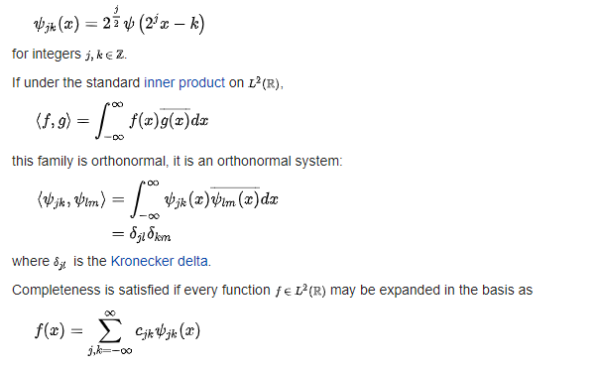

with convergence of the series understood to be [convergence in norm](https://en.wikipedia.org/wiki/Norm_(mathematics)#Properties). Such a representation of *f* is known as a wavelet series. This implies that an orthonormal wavelet is [self-dual](https://en.wikipedia.org/wiki/Dual_wavelet).

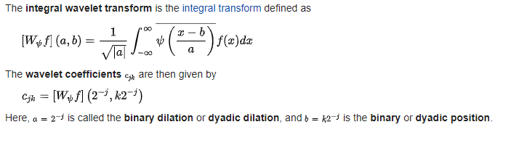

The fundamental idea of wavelet transforms is that the transformation should allow only changes in time extension, but not shape. This is affected by choosing suitable basis functions that allow for this.[*[how?](https://en.wikipedia.org/wiki/Wikipedia:Please_clarify" \o "Wikipedia:Please clarify)*] Changes in the time extension are expected to conform to the corresponding analysis frequency of the basis function. Based on the [uncertainty principle](https://en.wikipedia.org/wiki/Uncertainty_principle#Signal_processing) of signal processing,



wheret represents time and ω angular frequency (ω = 2πf, where f is temporal frequency).

The higher the required resolution in time, the lower the resolution in frequency has to be. The larger the extension of the analysis windows is chosen, the larger is the value of {\displaystyle \scriptstyle \Delta t}[[*how?*](https://en.wikipedia.org/wiki/Wikipedia:Please_clarify)].

[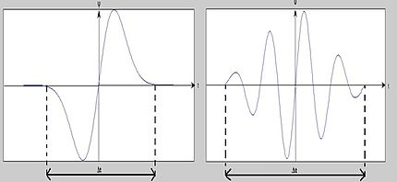](https://en.wikipedia.org/wiki/File:Basis_function_with_compression_factor.jpg)

When Δt is large,

1. Bad time resolution
2. Good frequency resolution
3. Low frequency, large scaling factor

When Δt is small

1. Good time resolution
2. Bad frequency resolution
3. High frequency, small scaling factor

In other words, the basis function Ψ can be regarded as an impulse response of a system with which the function x(t) has been filtered. The transformed signal provides information about the time and the frequency. Therefore, wavelet-transformation contains information similar to the [short-time-Fourier-transformation](https://en.wikipedia.org/wiki/Short-time_Fourier_transform), but with additional special properties of the wavelets, which show up at the resolution in time at higher analysis frequencies of the basis function. The difference in time resolution at ascending frequencies for the [Fourier transform](https://en.wikipedia.org/wiki/Fourier_transform) and the wavelet transform is shown below.

[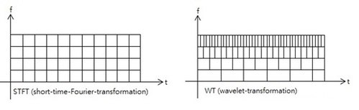](https://en.wikipedia.org/wiki/File:STFT_and_WT.jpg)

This shows that wavelet transformation is good in time resolution of high frequencies, while for slowly varying functions, the frequency resolution is remarkable.

Another example: The analysis of three superposed sinusoidal signals {\displaystyle \scriptstyle y(t)\;=\;\sin(2\pi f\_{0}t)\;+\;\sin(4\pi f\_{0}t)\;+\;\sin(8\pi f\_{0}t)} with STFT and wavelet-transformation.

[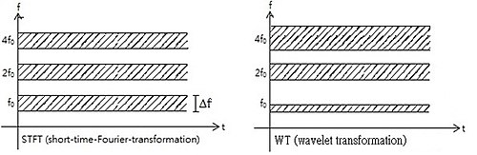](https://en.wikipedia.org/wiki/File:Analysis_of_three_superposed_sinusoidal_signals.jpg)

Wavelet compression is a form of [data compression](https://en.wikipedia.org/wiki/Data_compression) well suited for [image compression](https://en.wikipedia.org/wiki/Image_compression) (sometimes also [video compression](https://en.wikipedia.org/wiki/Video_compression) and [audio compression](https://en.wikipedia.org/wiki/Audio_compression_(data))). Notable implementations are [JPEG 2000](https://en.wikipedia.org/wiki/JPEG_2000), [DjVu](https://en.wikipedia.org/wiki/DjVu" \o "DjVu) and [ECW](https://en.wikipedia.org/wiki/ECW_(file_format)) for still images, [CineForm](https://en.wikipedia.org/wiki/CineForm" \o "CineForm), and the BBC's [Dirac](https://en.wikipedia.org/wiki/Dirac_(codec)). The goal is to store image data in as little space as possible in a [file](https://en.wikipedia.org/wiki/Computer_file). Wavelet compression can be either [lossless](https://en.wikipedia.org/wiki/Lossless_data_compression) or [lossy](https://en.wikipedia.org/wiki/Lossy_data_compression" \o "Lossy data compression).[[1]](https://en.wikipedia.org/wiki/Wavelet_transform#cite_note-1)

Using a wavelet transform, the wavelet compression methods are adequate for representing [transients](https://en.wikipedia.org/wiki/Transient_(acoustics)), such as percussion sounds in audio, or high-frequency components in two-dimensional images, for example an image of stars on a night sky. This means that the transient elements of a data signal can be represented by a smaller amount of information than would be the case if some other transform, such as the more widespread [discrete cosine transform](https://en.wikipedia.org/wiki/Discrete_cosine_transform), had been used.

Discrete wavelet transform has been successfully applied for the compression of electrocardiograph (ECG) signals[[2]](https://en.wikipedia.org/wiki/Wavelet_transform" \l "cite_note-2) In this work, the high correlation between the corresponding wavelet coefficients of signals of successive cardiac cycles is utilized employing linear prediction.

Wavelet compression is not good for all kinds of data: transient signal characteristics mean good wavelet compression, while smooth, periodic signals are better compressed by other methods, particularly traditional harmonic compression (frequency domain, as by Fourier transforms and related).

See [Diary Of An x264 Developer: The problems with wavelets](https://web.archive.org/web/20100228145846/http:/x264dev.multimedia.cx/?p=317) (2010) for discussion of practical issues of current methods using wavelets for video compression.

First a wavelet transform is applied. This produces as many [coefficients](https://en.wikipedia.org/wiki/Coefficient) as there are [pixels](https://en.wikipedia.org/wiki/Pixel) in the image (i.e., there is no compression yet since it is only a transform). These [coefficients](https://en.wikipedia.org/wiki/Coefficient) can then be compressed more easily because the information is statistically concentrated in just a few coefficients. This principle is called [transform coding](https://en.wikipedia.org/wiki/Transform_coding). After that, the [coefficients](https://en.wikipedia.org/wiki/Coefficient) are [quantized](https://en.wikipedia.org/wiki/Quantization_(signal_processing)) and the quantized values are [entropy encoded](https://en.wikipedia.org/wiki/Entropy_encoding) and/or [run length encoded](https://en.wikipedia.org/wiki/Run-length_encoding).

A few 1D and 2D applications of wavelet compression use a technique called "wavelet footprints"

|  |  |  |
| --- | --- | --- |
| Transform | Representation | Input |
| [Fourier transform](https://en.wikipedia.org/wiki/Fourier_transform) | {\displaystyle {\hat {f}}(\xi )=\int \_{-\infty }^{\infty }f(x)e^{-2\pi ix\xi }\,dx} | *ξ*, frequency |
| [Time-frequency analysis](https://en.wikipedia.org/wiki/Time-frequency_analysis) | {\displaystyle X(t,f)} | *t*, time; *f*, frequency |
| Wavelet transform | {\displaystyle X(a,b)={\frac {1}{\sqrt {a}}}\int \_{-\infty }^{\infty }{\overline {\Psi \left({\frac {t-b}{a}}\right)}}x(t)\,dt} | *a*, scaling; *b*, time |

Wavelets have some slight benefits over Fourier transforms in reducing computations when examining specific frequencies. However, they are rarely more sensitive, and indeed, the common [Morlet wavelet](https://en.wikipedia.org/wiki/Morlet_wavelet" \o "Morlet wavelet) is mathematically identical to a [short-time Fourier transform](https://en.wikipedia.org/wiki/Short-time_Fourier_transform) using a Gaussian window function.[[5]](https://en.wikipedia.org/wiki/Wavelet_transform#cite_note-5) The exception is when searching for signals of a known, non-sinusoidal shape (e.g., heartbeats); in that case, using matched wavelets can outperform standard STFT/Morlet analyses.[[6]](https://en.wikipedia.org/wiki/Wavelet_transform#cite_note-6)

The wavelet transform can provide us with the frequency of the signals and the time associated to those frequencies, making it very convenient for its application in numerous fields. For instance, signal processing of accelerations for gait analysis,[[7]](https://en.wikipedia.org/wiki/Wavelet_transform" \l "cite_note-7) for fault detection,[[8]](https://en.wikipedia.org/wiki/Wavelet_transform#cite_note-8) for design of low power pacemakers and also in ultra-wideband (UWB) wireless communications.[[9](https://en.wikipedia.org/wiki/Wavelet_transform#cite_note-9)

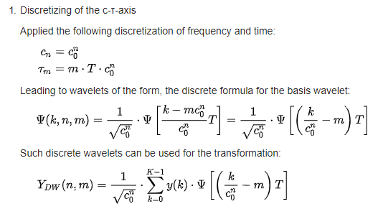

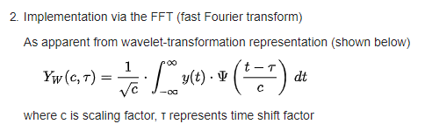

and as already mentioned in this context, the wavelet-transformation corresponds to a convolution of a function y(t) and a wavelet-function. A convolution can be implemented as a multiplication in the frequency domain. With this the following approach of implementation results into:

* Fourier-transformation of signal y(k) with the FFT
* Selection of a discrete scaling factor {\displaystyle c\_{n}}
* Scaling of the wavelet-basis-function by this factor {\displaystyle c\_{n}} and subsequent FFT of this function
* Multiplication with the transformed signal YFFT of the first step
* Inverse transformation of the product into the time domain results in *YW{\displaystyle (c,\tau )}* for different discrete values of τ and a discrete value of {\displaystyle c\_{n}}
* Back to the second step, until all discrete scaling values for {\displaystyle c\_{n}}are processed

There are many different types of wavelet transforms for specific purposes. See also a full [list of wavelet-related transforms](https://en.wikipedia.org/wiki/List_of_wavelet-related_transforms) but the common ones are listed below: [Mexican hat wavelet](https://en.wikipedia.org/wiki/Mexican_hat_wavelet), [Haar Wavelet](https://en.wikipedia.org/wiki/Haar_Wavelet" \o "Haar Wavelet), [Daubechies wavelet](https://en.wikipedia.org/wiki/Daubechies_wavelet" \o "Daubechies wavelet), triangular wavelet.

**EXPERIMENTAL RESULTS**

For evaluating this algorithm, we must compute the performance parameter such as: PSNR (Peak Signal to Noise Ratio) to validate the performance of the algorithm.

We here added a Gaussian noise and have found that the output images are not fully restored. So we perform DWT based restoration in order to get a better result. The Figure shows the original image, degraded one, restored image of pseudo-inverse filter followed by decomposition and finally the reconstructed image using DWT. The performance of the DWT based restoration is evidently better. Figure 7 shows the output of pseudo-inverse filter from a image corrupted by spekle noise. We here added speckle noise and have found that the output image are not fully restored which is improved further using DWT filtering.

**CONCLUSION**

Image restoration is an active research area. The denoising and normalization technique minimizes noise present in the image and Wavelet Transform restores the image to a certain extent. Always there is an attempt to restore the original image. The implemented Hybrid model works to restore degraded image as much possible to look like the original image.

**REFERENCES**

[1] Appreet Kaur, Manpreet Kaur, Poonamdeep Kaur, Manpreet Kaur, ”Comparative Analysis of Image Denoising Techniques” ,International Journal of Emerging Technology and Advanced Engineering”, Volume 2, Issue 6, June 2012.

[2] Anamika Maurya, Rajinder Tiwari, ”Novel Method of Image Restoration by using Different Types of Filtering Techniques”, International Journal of Engineering Science and Innovative Technology (IJESIT) Volume 3, Issue 4, July 2014

[3] Zohair Al-Ameen, Dzulkifli Mohamad, Mohd Shafry M.R and Ghazali Sulong, ”Restoring Degraded Astronomy Images using a Combination of Denoising and Deblurring Techniques”,International Journal of Signal Processing, Image Processing and Pattern Recognition Vol. 5, No. 1, March, 2012.

[4] Peter Kovesi, ”Phase Preserving Denoising of Images”

[5] Ms. Jignasa M. Parmar , Ms. S. A. Patil ,” Performance Evaluation and Comparison of Modified Denoising Method and the Local Adaptive Wavelet Image Denoising Method”, International Conference on Intelligent Systems and Signal Processing (ISSP),IEEE 2013.

[6] Prashan Premaratne, Ian Burnett, ”Role OF WAVELET Transforms In Image Restoration”,0-7803-8560, pp. 243-246,IEEE, 2004